Clear 1
Input and display the binary image 1
Blur the image, corrupt the image using WGN and display it 1
Restoration using generalized Wiener filtering 1

Clear
clear all
close all
clc

Input and display the binary image
I0 = imread('lenna.tif');
row = size(I0,1);
column=size(I0,2);
I=rgb2gray(I0);
I=double(I);

Blur the image, corrupt the image using WGN and display it
h is the blurring kernel, and sigma is the noise standard deviation
h = ones(3,3)/9;
sigma = 10;
Xf = fft2(I);
Hf = fft2(h,row,column);
y = real(ifft2(Hf.*Xf))+sigma*randn(row,column); % circular convolution

Restoration using generalized Wiener filtering
gamma = 1;
alpha = 1;
ewx = WienerFilter_fft(y,h,sigma);
PSNR = abs([psnr(I,I) psnr(y,I) psnr(ewx,I)]) %peak to noise ratio
MSE = [immse(I,I) immse(y,I) immse(ewx,I)] %Mean squared error
subplot(221)
imshow(I0)
title('RGB Image')
subplot(222)
imshow(I,gray(256))
title('Gray Image')
subplot(223)
imshow(y,gray(256))
title('Noise and blur Image')
subplot(224)
imshow(ewx,gray(256))
title('Restored Image')
return
PSNR =
Inf 23.8549 17.7414
MSE =
0 242.9324 59.4485
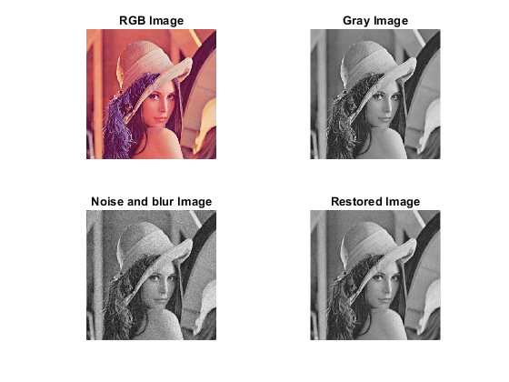
Published with MATLAB® R2020a

